SCHOOL NAME: WOMBOURNE HIGH SCHOOL LATERAL FLOW TESTING RISK ASSESSMENT JANUARY 2021

Assessment conducted by: L Barrett  Previous Assessments conducted by: D Willetts | Job title: Facilities & Operations Manager | Risk/Area Covered by this assessment:  General and Clinical activities on the asymptomatic testing at school
Date of assessment: 12/1/20  Date of review: 25/02/21 | Date of next review: Continuous  To be read in conjunction with the School COVID-19 Risk Assessment | Areas reviewed: Traversing the site on foot / The testing of staff and students
Who might be affected | Employees, Students, Visitors, Contractors

Why is this document needed: Public Health England and the Health and Safety Executive require this documentation to ensure end to end health, safety and infection control risks for mass lateral flow testing are identified, pre-assessed, managed and monitored regularly by the site owners and testing operators.

Key:
Hazard | Identifies the risk before any steps to reduce the risk have been taken
Risk Description: | Outlines the area of concern. This list is not exhaustive, and schools should add/amend/delete where appropriate e.g. risks for students with complex needs.
Risk Controls: | The measures that will be taken to minimise the risk. These are generic and should be adapted for the school context. Add – see current control measures.
Impact: | Low = 1 Medium = 2 High = 3
Likelihood: | Unlikely = Low = 1, Likely = Medium = 2, Highly Likely/Certain = High = 3 IF IMPACT AND LIKELIHOOD ARE BOTH HIGH, THEN THE ACTIVITY SHOULD BE STOPPED UNTIL ADDITIONAL CONTROL MEASURES ARE PUT IN PLACE.
Responsible person: | The identified staff member(s) responsible for implementing the risk controls.
Completion Date: | The date by which required plans for controls will be in place. To support planning, identify which controls need to be in place before students return to the setting. Individual schools can then personalise to their own setting.
Line Manager Check: | Sign off to ensure that the risk has been minimised as far as possible.

Hazard Identification and Evaluation

No | Hazards | Associated Risks | Current Control/Mitigation Measures | Risk Evaluation Post Measures |  |  | Responsible Person | Additional Controls Needed or Not
 |  |  |  | Likelihood | Impact | Risk
1 | Contact between subjects increasing the risk of transmission of COVID 19 | Transmission of the virus leading to ill health and potential death | - Asymptomatic Testing: All subjects are to be advised in advance not to attend if they have any symptoms of COVID 19, or live with someone who is showing symptoms of COVID 19 (including a fever and/or new persistent cough) or if they have returned within 14 days from a part of the world affected by the virus or have been in close contact with someone who is displaying symptoms.  - Testing Staff; will have had to complete the modules on the LFD testing and attained the certification before being part of the testing team.  - All testing team members will have to wear appropriate PPE dependant on their role as determined by the NHS  - Training sessions are being ran before testing begins to ensure that the Team Leader and Testers understand their roles in the procedure.  - Team Leaders will ensure all PPE, Swabs, LFDs and other testing equipment is sorted correctly and sock controlled  - Face masks: Prominent signage reminding attending subjects of the above to be displayed at the entrance to the building.  - Face coverings/masks to be worn by subjects at all times whilst on the premises except for brief lowering at time of swabbing.  - Requirement to wear face covering/mask to be reminded to all subjects in advance at time of test booking.  - Compliance with wearing of face covering/mask of all subjects to be visually checked on arrival by reception staff.  - Compliance with wearing of face covering/mask of all subjects to be visually checked through building by queue managers and all other staff.  - Hand hygiene: All subjects to use hand sanitiser provided on arrival & adherence to this enforced by reception staff. Signage instructing hand sanitisation will highlight this requirement at all stations within the test centre.  - Social distancing: Two metre social distancing to be maintained between subjects with measured floor markings in place to ensure compliance in addition to verbal reminders if necessary from reception, queue management & sampling staff.  - A one-way flow of subjects through the building is to be initiated and maintained at all times. Compliance with this is to be ensured by queue management staff.  - Cleaning: Regular cleaning of the site including wipe down of all potential touchpoints in accordance with PHE guidance.  - Limited clutter-chairs only on request;  - Appropriate cleaning chemicals to be used as directed by PHE  - Waste Control; appropriate waste control is being followed as stated in the guidance from the NHS. White bags are used for used / contaminated samples, swabs and LFD cartridges, where yellow tiger bags are used for used / soiled PPE.  - All bags to be tired and stored either in a large euro waste bin and secure location to await collection from PHS.  - PHS are the contractor who will be disposing of the waste bags via appropriate means in accordance with HSE regulations. | 1 | 2 | 2 | Head Teacher  Head Teacher / SLT  Head Teacher / SLT / Test Centre Team Leader  Head Teacher / SLT / Test Centre Team Leader  Test Centre Team Leaders / Cleaning Supervisor  Testing Centre Team Leaders / SLT  Test Centre Team Leader / Cleaning Supervisor | A formal letter outlining the requirements for LFD tests and not to attend School if symptoms of COVID-19 are present.  All staff advised to watch the NHS video on Asymptomatic Testing and made aware that this process will be conducted in due course.  Students will be tested on their first day and then on a rota as per the guidance’s from the NHS  Will ensure all testers have completed the training modules and passed before being allowed to be part of the testing team.  Reminder sent to all Staff & Students instructed to wear face masks whilst is the LFD test area, only removing the mask to perform the test.  Signage to be dispersed around the test site and at the testing stations.  Hand Sanitizer to be readily available in the test centre  Stock to be monitored by the Cleaning Supervisor and Site Team  Test Centre Team Leader to ensure all social distancing signage and arrows are in place and being adhered too.  Cleaning teams informed of the PHE requirements and at least one member of the cleaning team positioned within the testing centre. Full PPE provided to the cleaning team with instruction on how to wear and dispose.
2 | Contact between subjects and staff increasing the risk of transmission of COVID 19 Welcome and registration | Transmission of the virus leading to ill health or potential death | - All subjects are to be advised in advance not to attend if they have any symptoms of COVID 19, or live with someone who is showing symptoms of COVID 19 (including a fever and/or new persistent cough) or if they have returned within 14 days from a part of the world affected by the virus or have been in close contact with someone who is displaying symptoms.  - Centre staff who are in close proximity of test subjects will wear full PPE consisting of Surgical gloves, Face mask and apron  - Social distancing where possible must still be observed  - Testers will have undergone training modules before being part of the testing team | 1 | 2 | 2
3 | Contact between subject sampler increasing the transmission of COVID 19 Sample Taking | Transmission of the virus leading to ill health or potential death | - All subjects are to be advised in advance not to attend if they have any symptoms of COVID 19, or live with someone who is showing symptoms of COVID 19 (including a fever and/or new persistent cough) or if they have returned within 14 days from a part of the world affected by the virus or have been in close contact with someone who is displaying symptoms.  - Centre staff who are in close proximity of test subjects will wear Surgical gloves, Face mask and apron  - Social distancing where possible must still be observed  - Testers will have undergone training modules before being part of the testing team | 1 | 2 | 2
4 | Contact between sample and test centre runner increasing the transmission of COVID19: Sample transport | Transmission of the virus leading to ill health or potential death | - All subjects are to be advised in advance not to attend if they have any symptoms of COVID 19, or live with someone who is showing symptoms of COVID 19 (including a fever and/or new persistent cough) or if they have returned within 14 days from a part of the world affected by the virus or have been in close contact with someone who is displaying symptoms.  - Social distancing where possible must still be observed  - Testers will wear surgical gloves, face masks and apron  - Testers will have undergone training modules before being part of the testing team | 1 | 2 | 2
5 | Contact between samples and sample testers increasing the transmission of COVID 19 Sample processing & analysis | Transmission of the virus leading to ill health or potential death | - All subjects are to be advised in advance not to attend if they have any symptoms of COVID 19, or live with someone who is showing symptoms of COVID 19 (including a fever and/or new persistent cough) or if they have returned within 14 days from a part of the world affected by the virus or have been in close contact with someone who is displaying symptoms.  - Social distancing where possible must still be observed  - Testers will wear surgical gloves, face mask and apron  - Testers will have undergone training modules before being part of the testing team | 1 | 2 | 2
6 | Contact between samples and sample testers increasing the transmission of COVID19: Sample disposal and waste disposal | Transmission of the virus leading to ill health or potential death | - All subjects are to be advised in advance not to attend if they have any symptoms of COVID 19, or live with someone who is showing symptoms of COVID 19 (including a fever and/or new persistent cough) or if they have returned within 14 days from a part of the world affected by the virus or have been in close contact with someone who is displaying symptoms.  - Social distancing where possible must still be observed  - Testers will wear surgical gloves, face mask and apron  - Testers will have undergone training modules before being part of the testing team | 1 | 2 | 2
7 | Incorrect Result Communication | Wrong samples or miscoding of results | - 2 identical barcodes are provided to subject at check in  - The subject registers their details to a unique ID barcode before conducting the test  - Barcodes are attached by trained staff at the sample collection bay  - Barcodes are checked for congruence at the analysis station 1 and applied to Lateral Flow Device at this station  - Testers will have undergone training modules before being part of the testing team | 1 | 2 | 2
8 | Damaged barcode, lost LFD failed to scan of barcode | Orphaned record on registration portal & No result communicated to individual | - Rule based recall of subjects who have not received a result within 30mins of registration  - Subjects are called for a re-test | 1 | 2 | 2
9 | Extraction solution which comes with the lab test kit contains the following components  NA₂HPO₄ (disodium hydrogen phosphate), NaH₂PO₄ (sodium phosphate monobasic), NaCl (Sodium Chloride) | These components do not have any hazard labels associated with them, and the manufacturer states that there are no hazards anticipated under conditions of use as described in other product literature. This is the case for exposure to: eye, skin, inhalation, ingestion, chronic toxicity, reproductive and developmental toxicity, carcinogenicity, and medical conditions aggravated by exposure. | - PPE: nitrile gloves which meet the Regulation (EU) 2016/425 to be used at all times when handling the extraction solution. Safety glasses with side shields which are tested and approved under appropriate government standards to be worn at all times when handling the extraction solution. Impervious clothing to be worn to protect the body from splashes or spillages.  - Environmental: do not let product enter drains  - Spillages: wipe surfaces which the solution has been spilt on and dispose of cleaning material in line with the lab's waste disposal procedures  - Do not use if the solution has expired  - Testers will have undergone training modules before being part of the testing team. Training to be provided in handling samples, chemicals and good lab practice. Adhere to guidelines in these training procedures to prevent improper handling.  - Follow procedures on the MSDS form provided by Innova to mitigate against inhalation, skin contact or ingestion of these chemicals. | 1 | 2 | 2
10 | Operational Illness or injury | Staff exhibiting/feeling effects that may indicate COVID 19 is present | - Staff training and information provided.  - Staff to isolate and remove themselves from the test centre immediately and request a test. | 1 | 2 | 2
11 | Manual Handling | Injury caused by incorrect manual handling techniques. Attempting to lift beyond capability | - All materials are divided in to small light weight packages.  - Follow Manual Handling Information provided and stated on the delivery boxes. | 1 | 2 | 2
12 | Unauthorised access by members of the public | Members of the public unfamiliar with the environment | - Only authorised access permitted to the building.  - Reception manned at all times.  - Only persons with School ID cards permitted to enter.  - Only Students registered to the School can enter  - Only authorised third parties agreed via the Head Teacher or Team Leader can enter the test centre | 1 | 2 | 2
13 | Uneven surfaces Floor Protection in Testing and Welfare Areas | Trip Hazards | - The testing centre is in a dedicated area which has been checked for uneven surfaces and other trip hazards  - Testing Team Leader and School Site Manager to check over the area daily for defects. | 1 | 2 | 2
14 | Electrical safety plan and equipment maintenance  Defective electrical equipment | Failure of equipment due to poor maintenance  Electric shock from faulty equipment | - All equipment in the testing area is either within twelve months of purchase or has an in-date PAT certificate/test label  - All electrical equipment to visually checked before use | 1 | 2 | 2
15 | Use of Shared Equipment | Cross Contamination of equipment increasing the possibility of COVID transference | - There is to be no shared equipment. Where tables/chairs etc. have been used by other persons, they are to be disinfected between users. | 1 | 2 | 2
16 | Test subjects unfamiliar with surroundings | Test subjects crossing in to sterile areas | - Individual guidance provided from test station staff.  - Floor and wall signage to provide direction. | 1 | 2 | 2
17 | Fire Alarm Activation | Persons unfamiliar with Actions in the Event of a Fire | - Pre-working briefing on Actions in the Event of a Fire | 1 | 2 | 2
18 | Lack of Welfare Facilities | No Where for Staff to consume food/drinks | - Welfare space provided for staff, separate from testing areas  - Staff only Toilet and hand washing facility provided | 1 | 2 | 2
19 | Cleaning of Testing Centre | Transmission of the virus due to poor cleaning practices | - Cleaning of testing bays and ensuring waste is correctly disposed of, including working with clinical waste provider (PHS) to dispose of clinical waste. | 1 | 2 | 2

Personal Protective Equipment to be used

Air Fed Helmet | Face  Visor | Goggles | Safety  Glasses | Ear  Defender | Safety  Boots | Safety Shoes | Head Protection | Hair Net/Chef Hat | Overall | Hi-Viz | Apron  Tabard | White /Chef Coat/ | 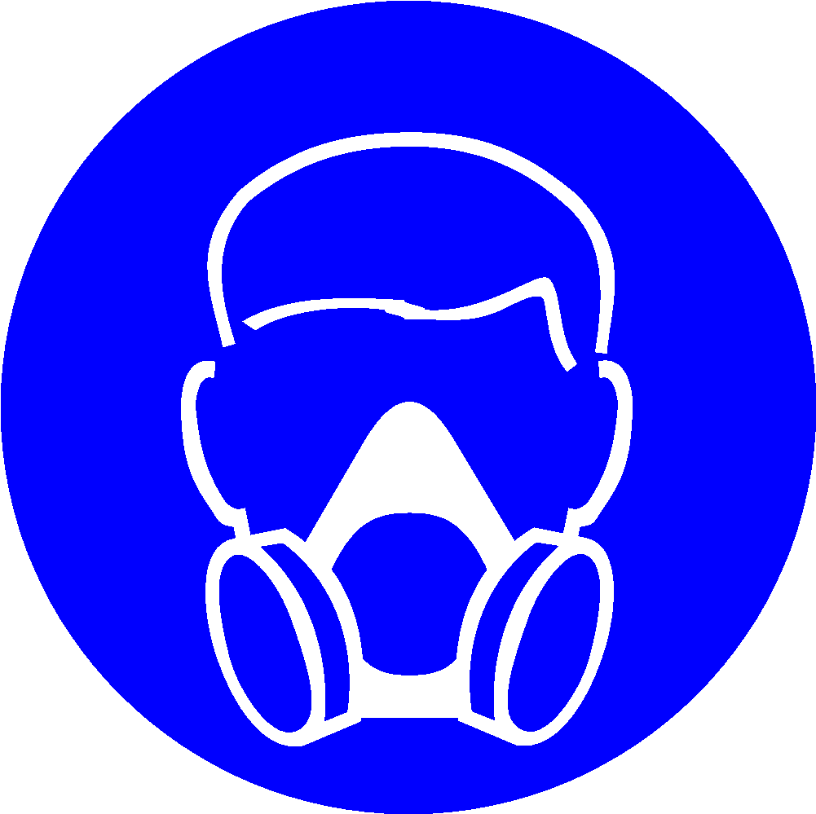  Half  Respirator | Respirator | Dust Mask | Face  Mask | Harness/  Lanyards | Rubber Gloves | Hand  Protection
 | ✔ | ✔ | ✔ |  |  |  |  |  |  | ✔ | ✔ |  |  |  |  | ✔ |  |  | ✔
OTHER

Declaration - If the above control measures are implemented the risks posed by the task / process / environment assessed will be controlled to as low as is reasonably practicable.
Persons involved in assessment | L Barrett
Signature of Headteacher |  | Date | 12/1/21

